Miraaj Chaudhry
Professor Jing
MATH.3850
4 May 2026
A Bivariate Regression Analysis of pH and Dissolved Oxygen
Water quality is a common concern in parts of the developing world, whether it is related to drinking water, water for everyday use, or water for ecosystems and the rest of the natural world. Regardless of location, analyzing water quality can give us a better idea of how these poor conditions come to be, which can lead to protective measures to be innovated and implemented. We will run a regression model in R to analyze the “Water Quality Data” dataset published by the U.S. Fish and Wildlife Service on the Data.gov site. This dataset takes 2372 water sample readings from four different sites near Virginia Beach, VI from 1989 to 2019. These readings contain different measurements of different attributes which include water levels, pH scores, salinity, among many others.
Dissolved oxygen levels, which are measured in mg/L, are usually the key component considered when determining water quality (“Indicators: Dissolved Oxygen”). This will be the outcome or target of our regression model. pH scores measure whether the water is acidic or basic (“What is pH?”), and our model will test the null hypothesis of pH scores not having a significant effect on dissolved oxygen levels (in the area this dataset was recorded). This null hypothesis can be expressed as H₀: 𝛽 = 0, with our alternative hypothesis being H₁: 𝛽 $≠$ 0, which expresses pH scores having a significant relationship with dissolved oxygen levels (Banerji). Figure 1 below shows the plot of this model with a line of best fit where “DO” represents dissolved oxygen levels in mg/L and pH represents pH readings on the pH scale.

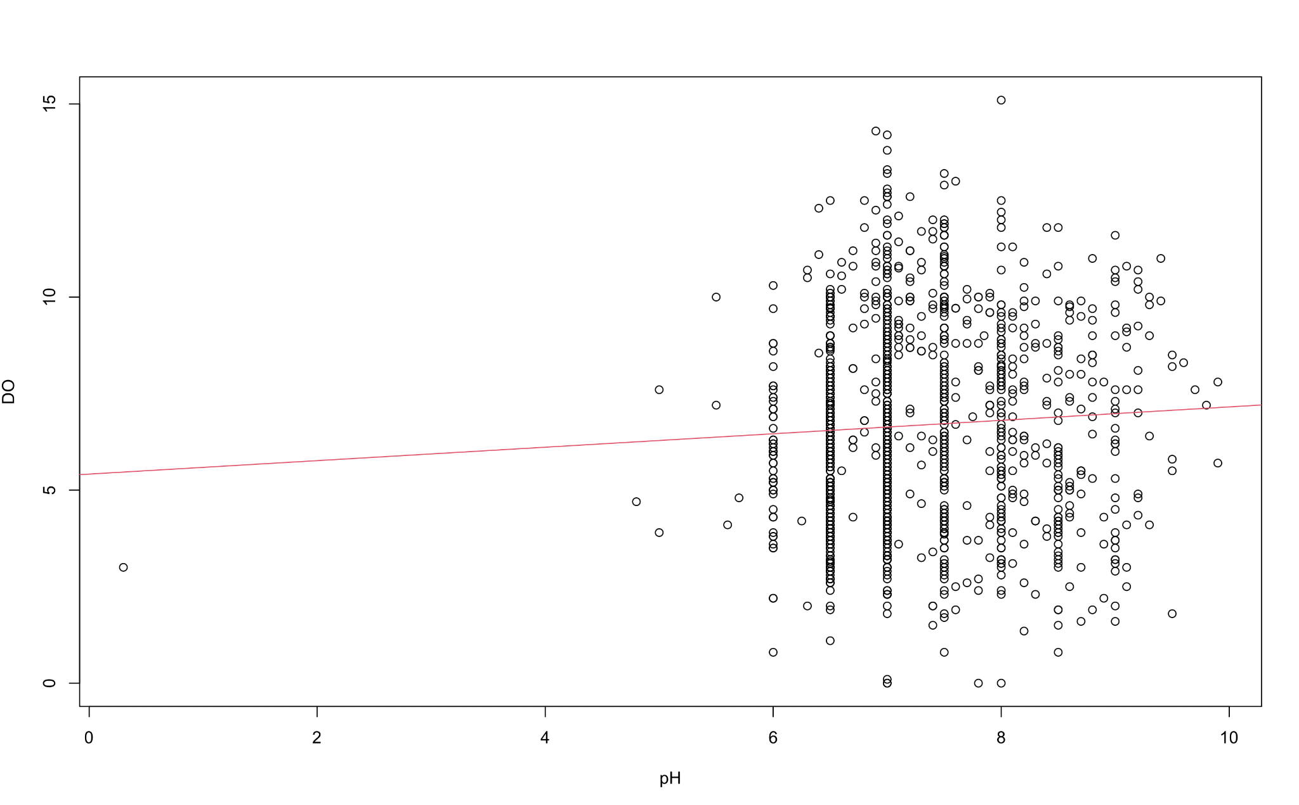
Figure 1: Linear regression model plotted

The plot in figure 1 indicates that there is a positive correlation between the two variables since the line of best fit is formed with a positive slope. However, while this significant relationship does exist, the fact there are several points scattered around the chart, and not resembling a straight line, indicates other variables are also having an influence on dissolved oxygen levels. These alternate features likely have a heavier influence than pH reading do. Furthermore, there is one outlier (near the lower left corner) that stands out when observing the plot. As outliers can directly affect linear regression models by causing the line to shift, it is possible that this outlier may have shifted the model’s line and not including it could improve the model. There is a chance this outlier may be a mistake in data recording and collecting, but it could also be the actual value observed, so it should not be removed unless we know for certain it’s a clerical mistake.
Using the summary() function in R, we can generate evaluation metrics to better understand this model and its performance. These metrics can be found in figure 2 and include several measurements related to p-value and residuals. The calculated p-value for this model was 0.03237, which is less than 0.05, indicating the model is useful. By definition of p-value, we can reject our null hypothesis (Banerji), which means that pH levels do have an impact on dissolved oxygen levels. As discussed earlier, this relationship may not be a strong one, but it still exists. This positive relationship can also be seen under “Estimate” in the “Coefficients” section as the slope of the line is 0.17398. Again, this isn’t a large slope, but there is a positive relationship between the predictor and the outcome. Additionally, from these metrics we can understand the models through its residuals, which at a point is the actual value - predicted value (or the distance between the model’s predicted points and the red line).
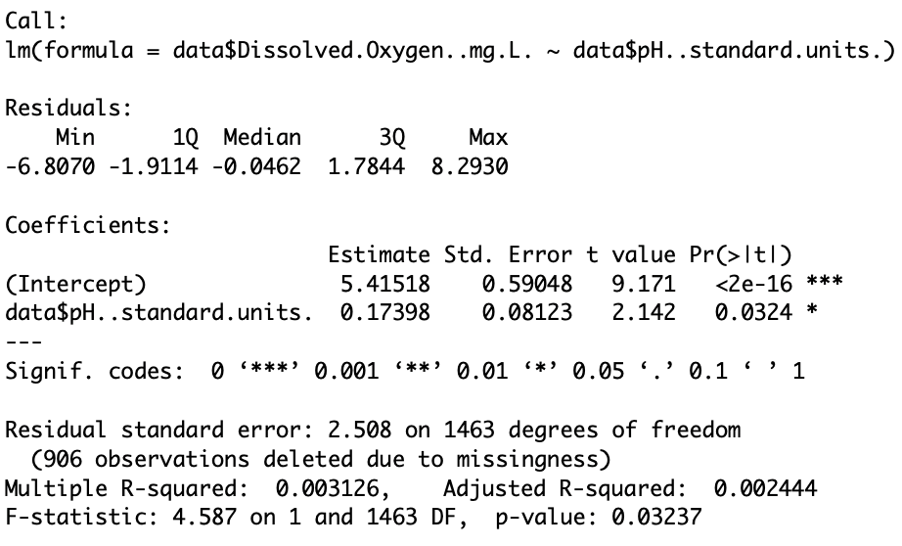
Figure 2: Evaluation metrics for linear regression model

The residual standard error (RSE) measures how much the average point deviates from its actual value, or the red line (“Find the Regression”). As with residuals, a lower RSE indicates a stronger model and this model earned a 2.508, which is high since both axes are on an interval of 0-10. However, having a p-value of 0.03237 makes the model useful and allows us to make reasonable inferences on our data. Another metric, R-squared values, measure how much variance the model captures, or in this case how much of the prediction is coming from the pH values versus random noise (“Find the Regression”). This model has a multiple R-squared value of 0.003126 and an adjusted one of 0.002444, or ~0.31% and ~0.24%, respectively. This indicates that over 99% of the model’s variance is not explained by the pH levels, meaning pH levels aren’t a large factor in the changes in dissolved oxygen levels. This supports findings discussed earlier as a weak relationship exists between the two variables.
Figure 3 below shows the residuals vs fitted graph of this model. In these graphs, the shape of the model allows us to better understand residual patterns and the relationship between the two variables. Ideally, the points in this graph should be scattered, illustrating randomness and a linear relationship (“Diagnostic Plots”). In figure 3, the points are scattered, but they’re still clustered together on the right-side of the figure. Once again, this finding strengthens the earlier conclusion that a linear relationship does exist between the two variables, but it is a weak one as other variables and measurements likely have a heavier influence on dissolved oxygen levels than pH readings.
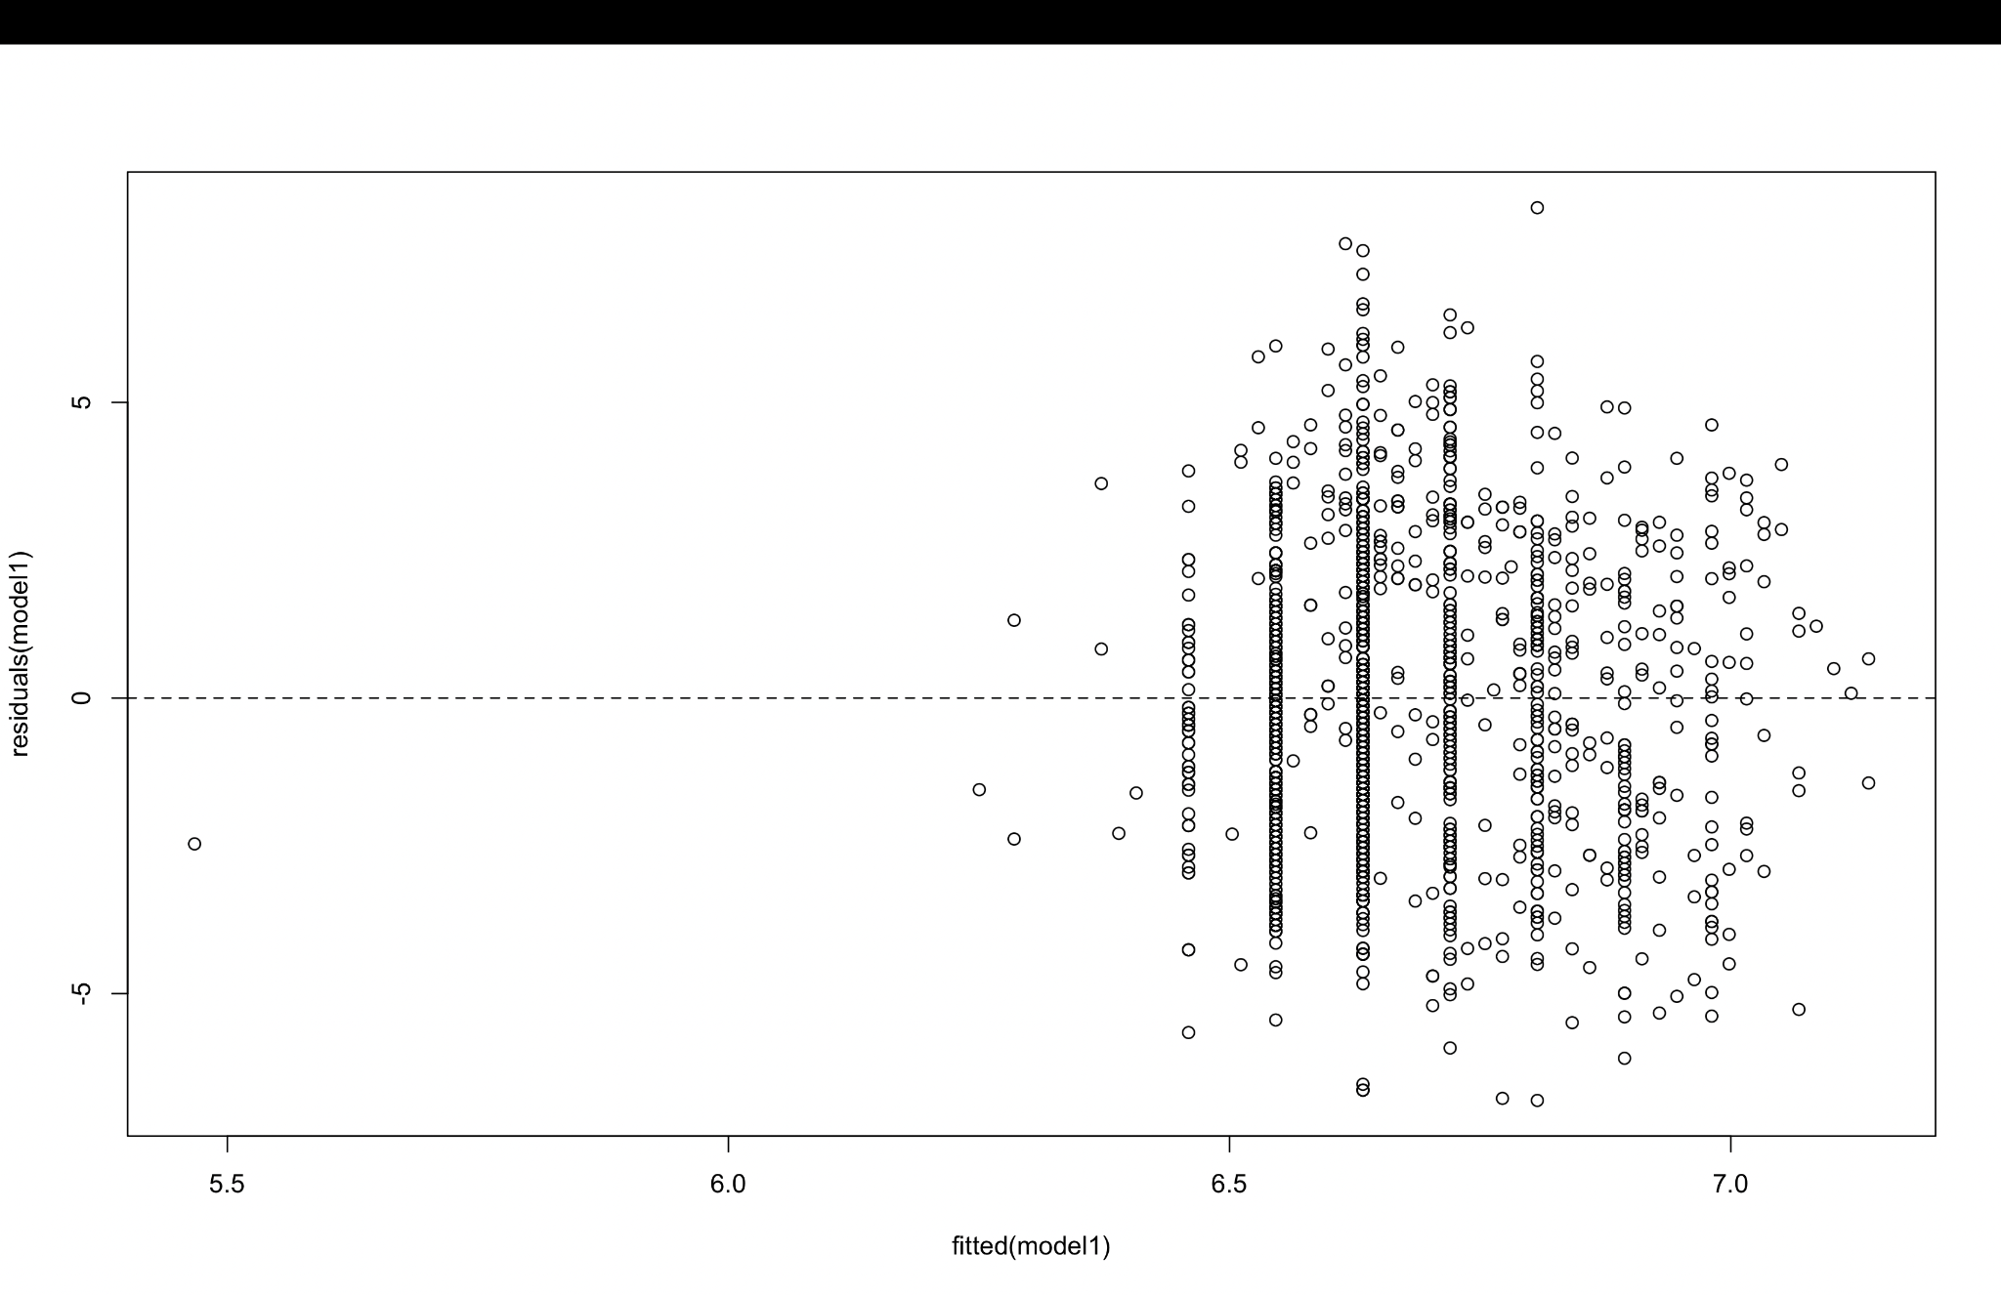
Figure 3: Residual vs Fitted Graph

These metrics have deemed this model useful and its metrics allow us to understand its relationships much better, but how reliable is this model and its results. One way to check is with a QQ plot to determine if residuals follow a normal distribution (Jing). The closer the residuals are to being normally distributed, denoted by them forming a straight line, the more reliable the model is (“Diagnostic Plots”). The generated QQ plot can be found in figure 4, which shows the points forming a straight line, but drifting away at both ends. This is a strong result with room for improvement as the fact it's not a perfectly normal distribution indicates there may be some skewness in the residual data.
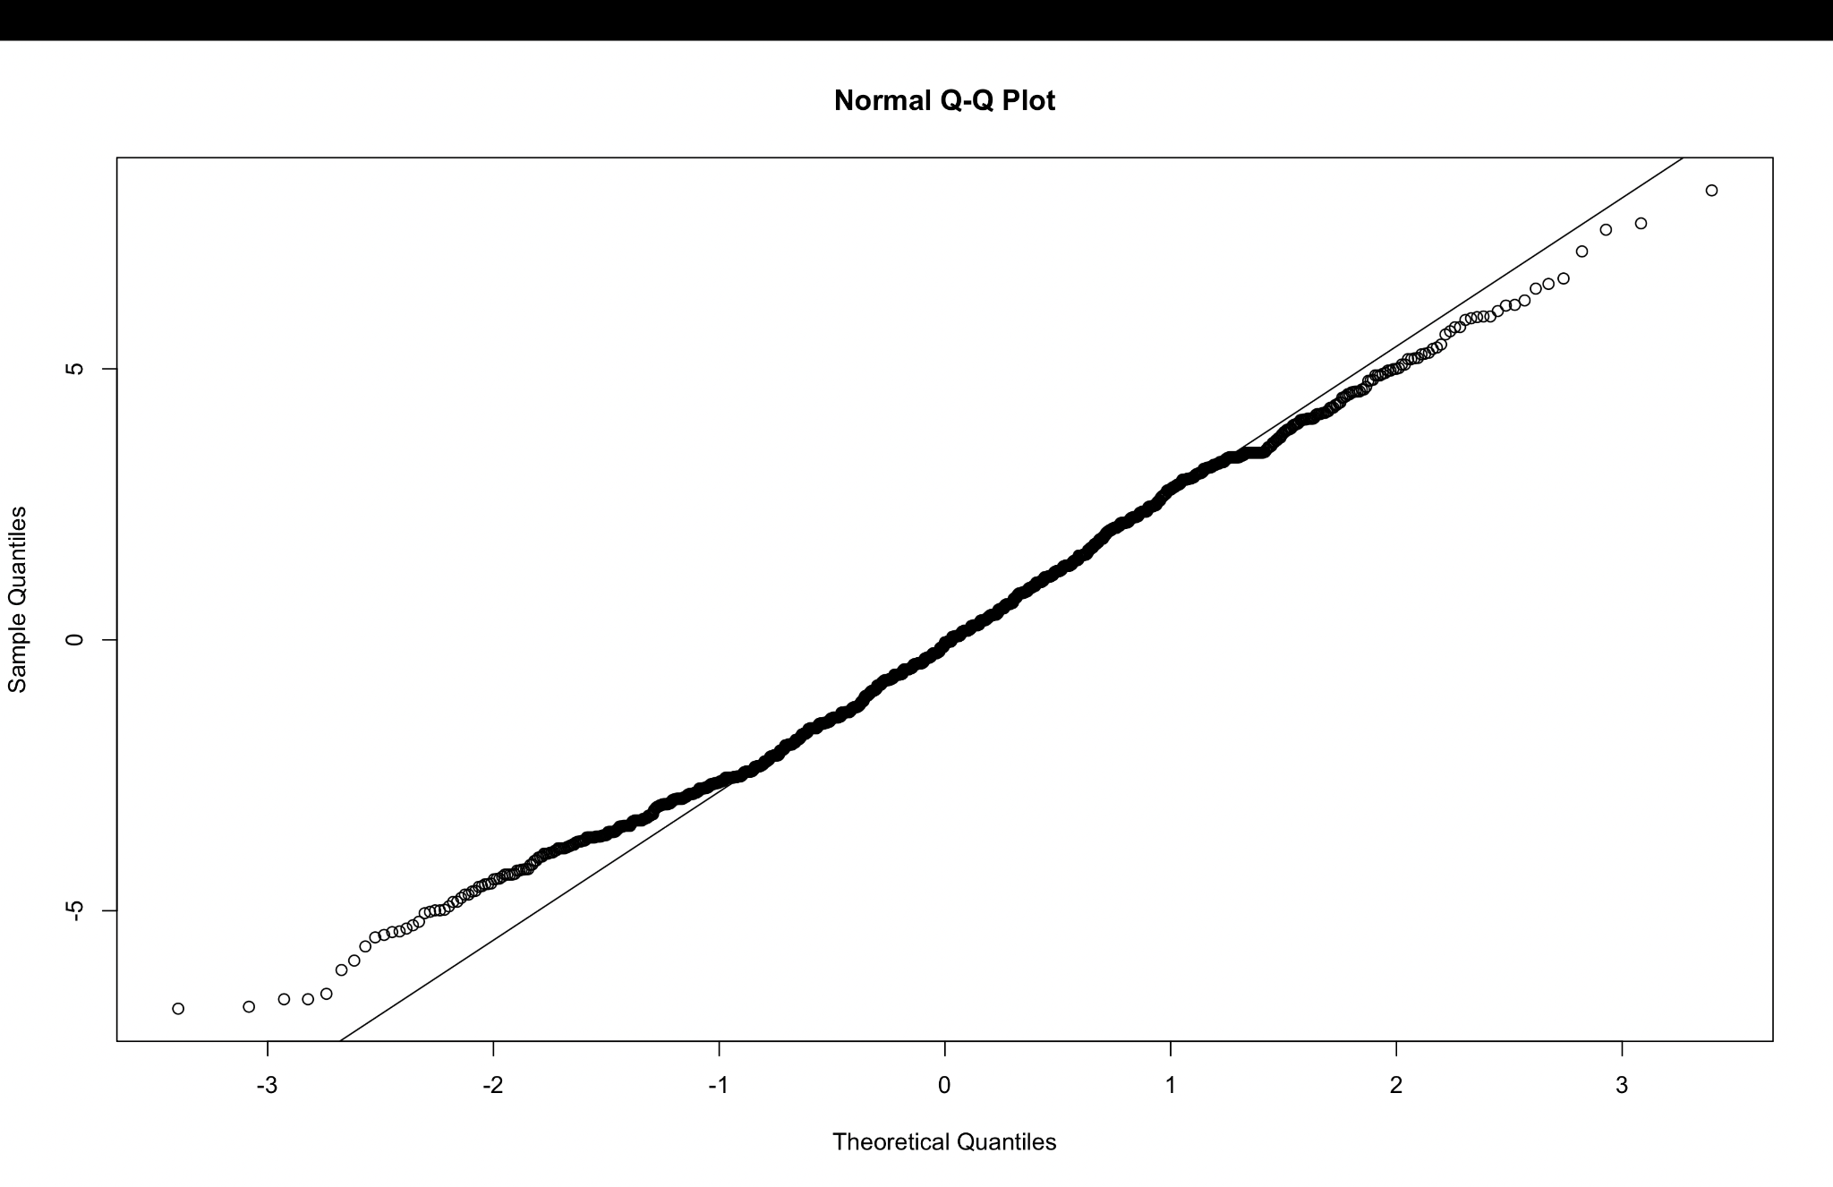
Figure 4: Initial QQ plot

Data transformations can be introduced to try to straighten this line out even more, thus
making the model more reliable. Two types of transformations to achieve this a log and square root transformations on the outcome (Jing). Figure 5 shows the resulting QQ plot following a log transformation on the dissolved oxygen level class. As seen in the graph, the points do not form a straight line, but rather a curve. This means our model went in the wrong direction as we want the line to be as straight as it can be. A model with a log transformation is not as reliable as one with no transformations as it shows more likelihood of skewness.

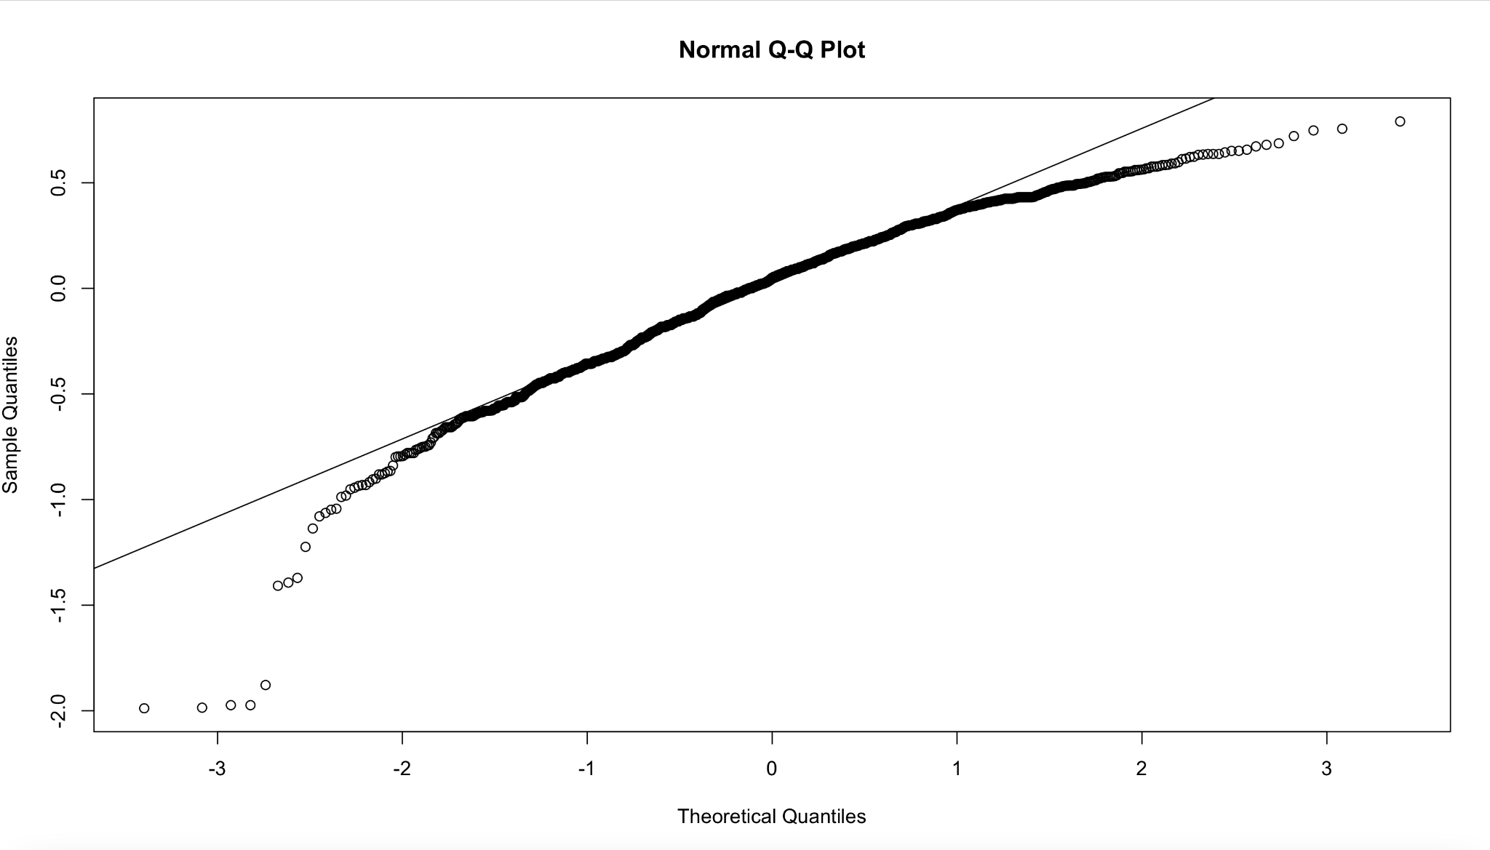
Figure 5: QQ plot after log transformation

Figure 6 shows the resulting QQ plot of a square root transformation. This transformation appears to generate better results than the previous. The line resembles a straight line much more than in figure 5, but it’s not as defined as it was in figure 4. This can be seen at the two ends of the line as in both graphs, the points start to stray away from the lines of best fit, but figure 6 has more points that appear to be outliers than figure 4 does. Simply put, the points that are away from the line in figure 6 seem to be by a further distance, than points in figure 4. This indicates that transformations on the outcome hurt the model and our initial model with no transformations is the most reliable is the residuals follow a close to perfect normal distribution, which is also evident by its low p-value.

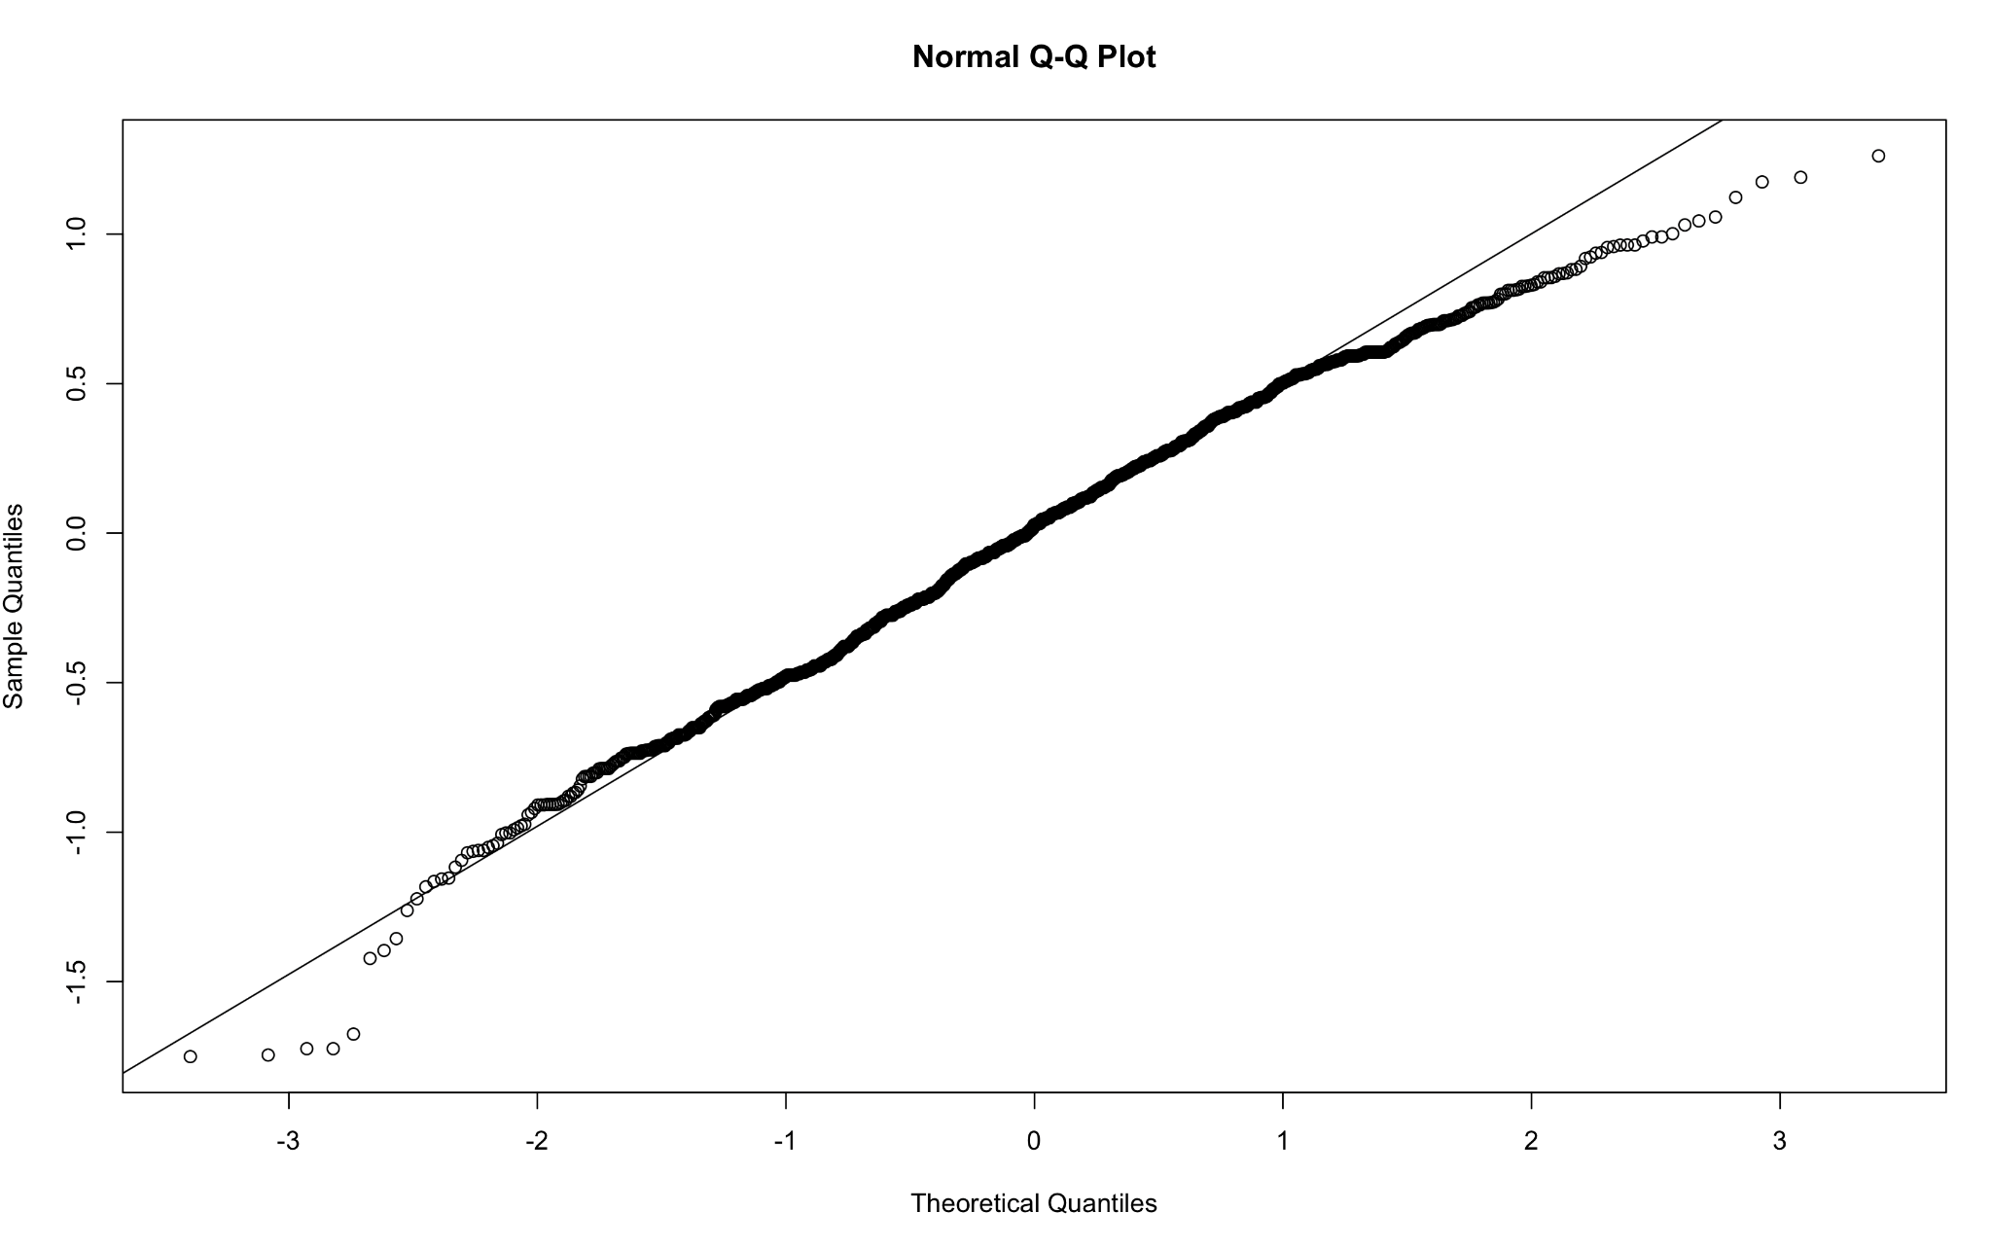
Figure 6: QQ plot after square root transformation

In conclusion, the findings of this study reject our null hypothesis of pH levels having no impact on dissolved oxygen levels. This is supported mainly by a p-value less than 0.05 (0.03237) and while the model’s residuals do follow a normal distribution deeming it reliable and useful, its high residuals indicate a linear relationship between the variables exists, but it is weak. Machine learning techniques could be applied to this model in the future to improve its performance and make it usable in the real-world. More advanced regression models, such as multiple linear regression or polynomial linear regression could also be analyzed to determine which model captures the relationship the best. Regardless, the evaluation of this model has helped us learn pH scores do have an impact on dissolved oxygen, and while it's a small impact, understanding this can be useful in determining why certain bodies of water have low water quality and how they can be improved.
R Code
data<-read.csv(“BKB_WaterQualityData_2020084.csv”, header=True)
summary(data)
DO<-data$Dissolved.Oxygen..mg.L.
pH<-data$pH..standard.units.
model1<-lm(DO ~ pH)
summary(model1)
plot(pH, DO); abline(model1, col=2)
plot(fitted(model1), residuals(model1)); abline(h=0, lty=2)
qqnorm(residuals(model1)); qqline(residuals(model1))
model2 <- lm(log(DO + 1) ~ pH)
qqnorm(residuals(model2)); qqline(residuals(model2))
model3 <- lm(sqrt(DO) ~ pH)
qqnorm(residuals(model3)); qqline(residuals(model3))

References
Banerji, Ankita. “Hypothesis Testing on Linear Regression.” Medium, 14 May 2021, medium.co
m/nerd-for-tech/hypothesis-testing-on-linear-regression-c2a1799ba964.
“Department of the Interior - Water Quality Data.” Data.Gov, U.S. Fish and Wildlife Service, catal
og.data.gov/dataset/water-quality-data.
“Diagnostic Plots for Model Evaluation.” GeeksforGeeks, GeeksforGeeks, www.geeksforgeeks.o
rg/r-machine-learning/diagnostic-plots-for-model-evaluation/.
“Find the Regression Output in R.” GeeksforGeeks, GeeksforGeeks, www.geeksforgeeks.org/m
achine-learning/find-the-regression-output-in-r/.
“Indicators: Dissolved Oxygen.” EPA, Environmental Protection Agency, www.epa.gov/national-a
quatic-resource-surveys/indicators-dissolved-oxygen.
Jing, Guangming. “Lecture 22.” MATH3850, April 2026, University of Masschusetts Lowell,
Lecture
“What Is pH?” EPA, Environmental Protection Agency, www.epa.gov/goldkingmine/what-ph.

